Business Question and Visualization Report

Field | Details
Date | 21 September 2026
Team ID | PNT2022TMIDxxxxxx
Project Name | Combined Strategic Workforce Analytics and Performance Intelligence
Maximum Marks | 5 Marks
Strategic workforce metrics and performance intelligence involve extracting actionable patterns from human resources systems. By intersecting operational data—such as AI adoption rates, work styles, burnout tiers, overtime, and tenure—with corporate performance indicators, business leaders can systematically flag
high-risk turnover zones. This document formalizes the business challenges and visual frameworks needed to construct an executive human resources reporting dashboard.
Business Questions and Visualization
This section maps your explicit Power BI report metrics to standardized analytical questions, meeting the academic requirement of compiling at least 8 robust data observations.

Sample Dashboard Reports
- What are our baseline corporate workforce and turnover indicators?

*
  - Visualization: KPI Summary Cards presenting high-level aggregations (Total Employees, Active vs. Departed, Average Monthly Income, Average Tenure, and AI Adoption Rate).
  - Screenshot of visualization:
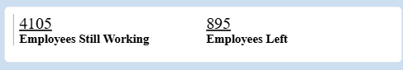
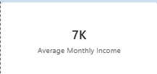

Which company divisions face the highest attrition rates?

*
  - Visualization: Horizontal Bar Chart ranking attrition rates across internal operating departments.
  - Screenshot of visualization
  - ​

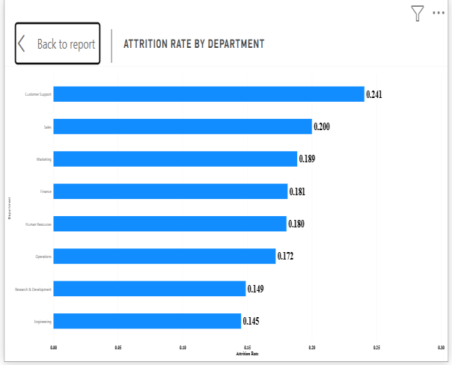

How do employee flight risks differ across specific functional job roles?

*
  - Visualization: Horizontal Bar Chart sorting turnover percentage strictly by individual job titles.
  - Screenshot of visualization:
  - 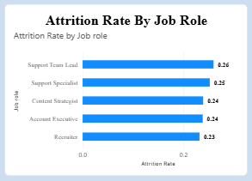

What is the impact of organizational AI tool usage on staff attrition?
*Visualization: Clustered Horizontal Bar Chart mapping how high, moderate, or low AI tool adoption aligns with real turnover counts.

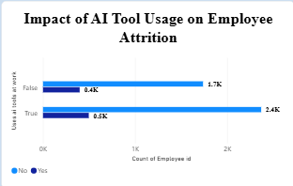
  - Screenshot of visualizatiion.

*

Does the choice of work environment style affect workforce retention?

*
  - Visualization: Donut Chart displaying the total volume of active versus departed staff clustered by Onsite, Hybrid, and Remote configurations.
  - Screenshot of visualization:

*

To what extent do excessive weekly overtime bands escalate turnover probabilities?

*
  - Visualization: Deep horizontal bar chart showing turnover metrics across explicit weekly overtime scales (0-5, 6-10, 11-20, and 21+ hours).
  - Screenshot of visualization:

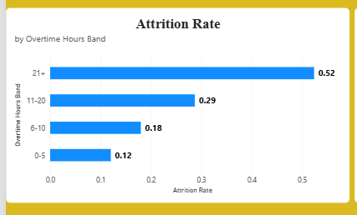
*

How closely does measured workplace burnout track against attrition trends?

*
  - Visualization: Line Trend Chart drawing the trajectory of attrition across increasing burnout score categories.
  - Screenshot of visualization:
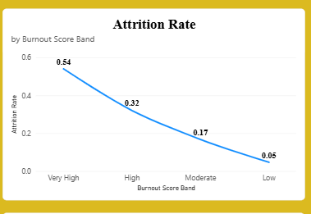
*

Are mid-career professionals or entry-level staff leaving at a faster rate?

*
  - Visualization: Continuous Line Chart plotting historical attrition percentages over a clear chronological age gradient (X-axis).

What is the impact of family structures on overall turnover volume?

*
  - Visualization: Stacked Column or Bar Chart comparing absolute total employee records grouped by Marital Status (Single, Married, Divorced) and filtered by active status.
  - Screenshot of visualization:



